**Geek Uninstaller Guidance**

**Simple User Interface**  
Great-looking and surprisingly functional, GeekUninstaller will help you keep your computer clean and organized! Instant startup, minimalistic, simple but efficient user interface. Single EXE runs flawlessly on both 32 and 64-bit Windows 7/8/XP/Vista. When running on x64 Windows GeekUninstaller is running as a native 64-bit application. Programs highlighted with purple orange color are recently installed/modified (since last run of Geek Uninstaller).

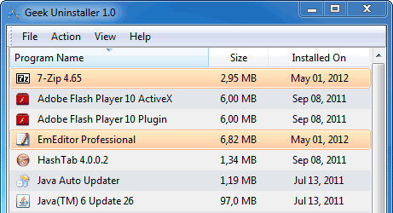

**Clean Removal, Force Removal**  
Standard removal program leaves tons of leftovers on your PC. GeekUninstaller performs deep and fast scanning afterwards and removes all leftovers. Keep your PC clean! Use Force Removal for stubborn and broken programs.

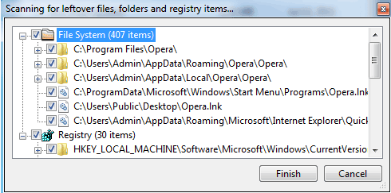

**Speaks Your Language**

30-languages on board! Arabic, Armenian, Azerbaijani, Belarussian, Brazilian, Bulgarian, Chinese_Simplified, Chinese_Traditional, Czech, Dutch, English, Estonian, French, Georgian, German, Greek, Hebrew, Hungarian, Italian, Japanese, Korean, Latvian, Lithuanian, Norwegian, Persian, Polish, Romanian, Russian, Serbian (Cyrillic), Serbian (Latin), Slovak, Spanish, Swedish, Turkish, Ukrainian

